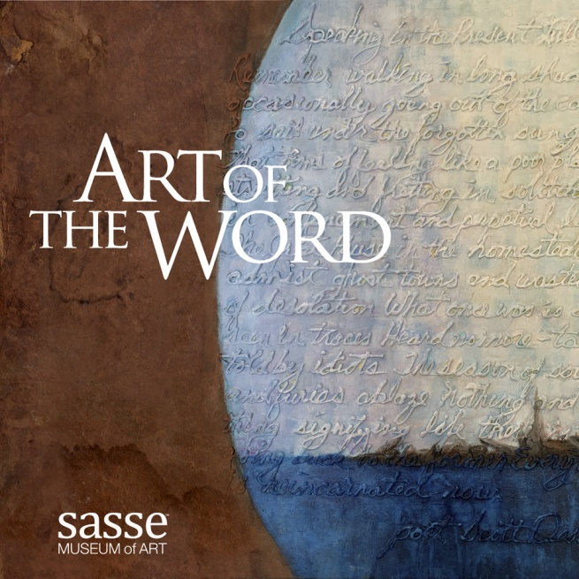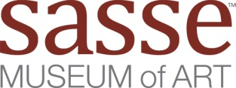

Call for Entries

Digital Juried Exhibit

Sponsored by: **Hambly & Hambly** <https://hamblyandhambly.com/>

## Deadline for entries is: Oct 22nd 2022

Submission Form

Name ___________________________________________________­­­­­­­­­­­­_____________

City _____________________________________________state _________________

Country ________________________________________________________________

email __________________________________ phone __________________________

website ______________________________ instagram _________________________

name for catalog __________________________________________

title ____________________________________________________

year created ____________________________________________

size ___________________________________________________

media _________________________________________________

Jpeg files 2700px (9in) minimum size, long dimension at 300ppi quality 12

Label **each file** first name_last name-title

The judging is based on the quality of the photography, make sure you submit quality images

Email each submission image & form to [exhibits@sasseartmuseum.org](mailto:exhibits@sasseartmuseum.org) subject | *Art of the Word*