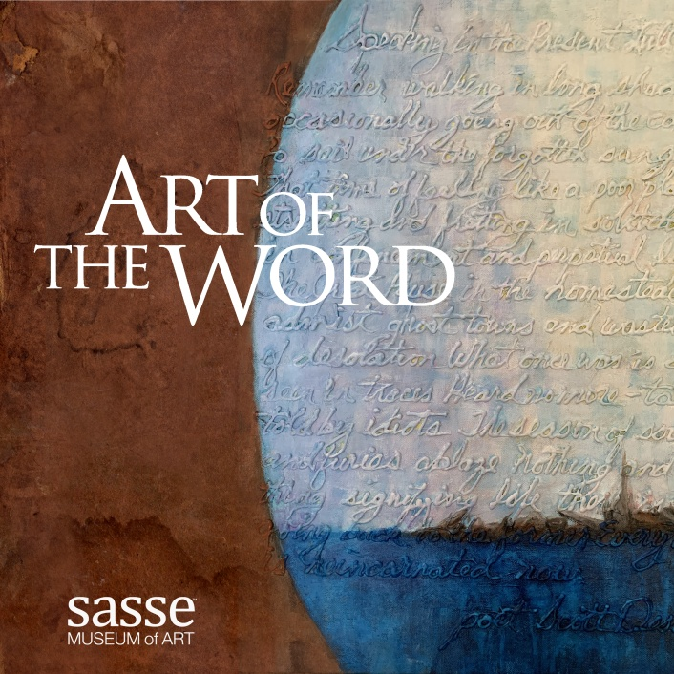
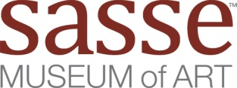

Call for Entries
Digital Juried Exhibit | Art of the Word

Sponsored by: Hambly & Hamble https://hamblyandhambly.com/

Hambly & Hambly is an art gallery that curates the best in Irish
Art and Culture that has a strong international reach. They are a forward-thinking, progressive visual art gallery and multi-purpose cultural space, they are located in the 18th century landmark Dunbar House in Northern Ireland.

Deadline for entries: Oct 22nd 2022

Art of the Word is a juried exhibit of art containing words or characters. The final product will be an electronic catalog hosted on the Museum Catalogs tab on the Sasse Museum’s website. Our 1st juried exhibit catalog was SeeMe. To see that catalog or others go to: https://sasseartmuseum.org/museum_catalogs.htm
This exhibit is open to all artists or photographers worldwide. The entry fee is $25 USD for the 1st entry fee; additional entries are $15 each whether or not your work is selected for publication. Sasse Museum of Art members receive a $10 discount on entries. Only one piece per artist will be selected for the digital publication.

eBook Details
- Open to all types of work
- Juried by| Fatemeh Burnes | https://www.fatemehburnes.com/
Fatemeh is a visual artist, educator, curator and activist based in Los Angeles. Since 1992, she has exhibited her own work nationally and internationally, curated over 100 exhibitions, authored numerous publications, and conducted art-education documentaries.

Submission Details

- Jpeg files 2700px (9in) minimum size, long dimension at 300ppi quality 12
- Label each file first name_last name-title. Without this information you entry will not be judged.
- The judging is based on the quality of the photography, make sure you submit quality images
- Email each submission image & form to exhibits@sasseartmuseum.org subject | Art of the Word Submission form https://sasseartmuseum.org/pdfs/art&word-submission_form.pdf

Need more information contact Gene Sasse 909-941-3993 | gene@sasseartmuseum.org

